

The Lift Condominiums
PARKING – Please place a parking tag on the dashboard of each vehicle. There is a maximum of two reserved spaces for each condo. Please verify the location of the parking spots for your unit. Your car may be towed if it is blocking the street, obstructing another vehicle, or parked in the wrong spot.
QUIET HOURS - They are from 10:00 p.m. to 8:00 a.m. If you have noise complaints, please call the Breckenridge Noise Management hotline at (970) 423-5334.

TRASH — Code 4406 The trash receptacle is inside the small shed at the north end of Snowberry Lane. Please do not leave trash outside near the stairwells or shed, as it will attract animals.

COLUMBINE POOL – The code varies by unit and will be provided to you by your rental agent. Hours vary and are posted at the gate. All beverages must be in a sealable, non-glass container.

PETS – The HOA does NOT allow guests to have pets of any kind.

LAUNDRY – Additional laundry facilities are in the north stairwell of the ‘A’ building at the far end of Snowberry Lane. The code is: 7050. The washers and dryers accept quarters, credit cards, or can be used with a downloadable mobile application. Details are posted on the wall inside the laundry facility. The cost of the wash/dryer is $2.00 per load.

HOUSEKEEPING – Your rental company provides linens and other provisions.

BUILDING EMERGENCIES - Water leaks, electrical issues, door locks: please call Blue River Property Management at (970) 453-6590

POLICE – Emergencies call 911 Non-emergencies – (970) 668-8600

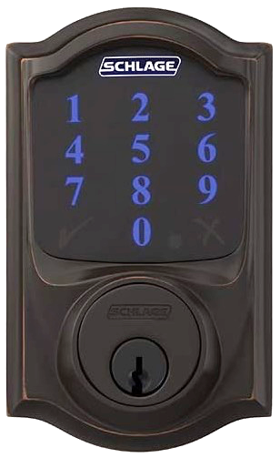
Locking
The code is NOT required. To lock the door from the outside, just press the ‘Schlage’ button.
The door does not automatically lock.
Unlocking
Press ‘Schlage’ to activate the backlighting if needed. Then enter your
4 to 8 digit user code.

If an incorrect code is entered too many times, you will be locked out for a short period of time.

